# **Yıldız Technical University**

# **Computer Engineering**

# **Electronic Circuits 2020/2**

# **Lab No: 1**

# **Preparations**

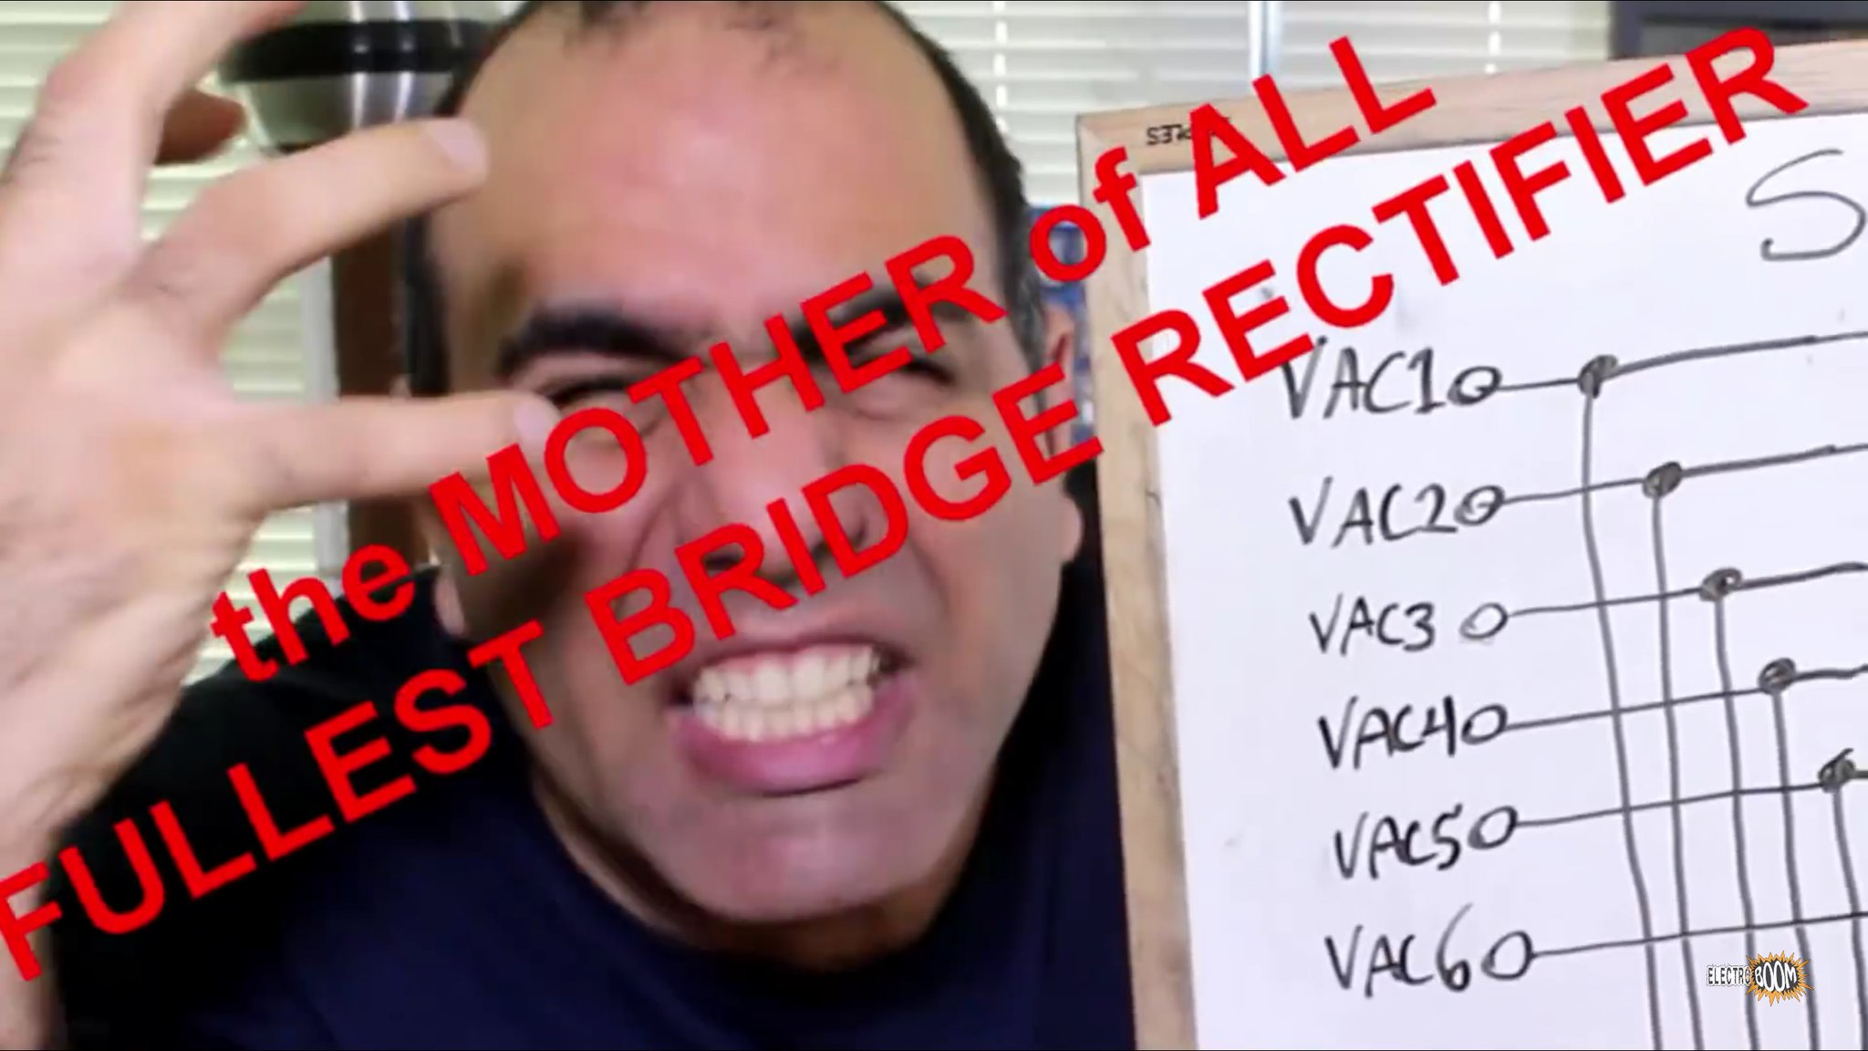

1. What is the difference between below circuits? How it effects circuit behaviour? Study carefully current and voltage of diode and resistor using proteus Graph Mode.

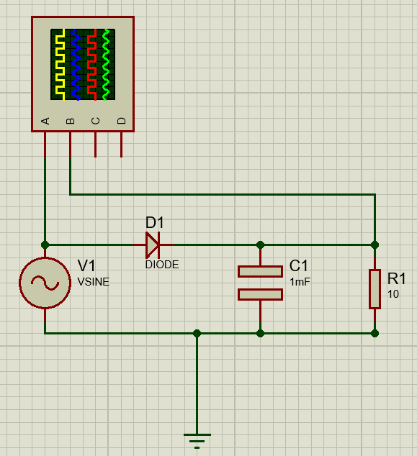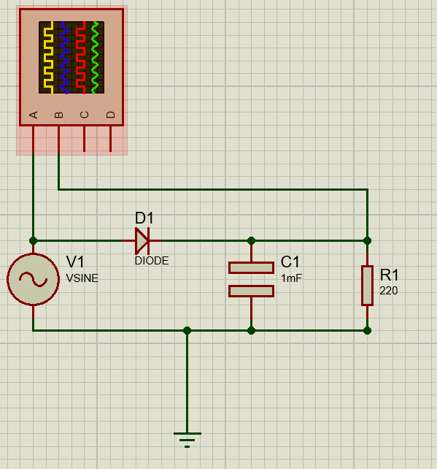

1. What is transformer, how it is Works?
2. What is input filter?
3. What is half bridge rectifier? Could it be optimized?
4. What is ripple voltage?
5. You required to convert 12V AC to 12V DC. What could be your pseudo approach?
6. Can zener diode used as voltage regulator? If so, simulate a circuit proofing this.

Study your findings in proteus simulation enviroments. Try to create circuit simulation for every question on proteus to practice enviroment.